***GOOGLE APIGEE API MANAGEMENT***

* APIGEE is an API Mgmt. Platform from Google which is widely used.

**Intro to API:-**

* API stands for Application Programming Interface.
* They are used to send request n get the response from the system.
* They are used to interact with the system.
* API Consumer is an entity which sends the request and in-return wants to consume the response sent by the end system.
* API Provider is an entity which exposes system end-point to provide that endpoint to its API Consumers.
* For eg:They are like waiter let say we have visited a hotel nearby to consume food so to get the food what we require is we have to make an order first to waiter so that he will get that order list and will get back with the ordered food to us so that we can consume that food.In this process waiter is a person who is getting the order n then giving the food so its an API which connects the Consumer(food consumer) to Provider( hotel kitchen).
* Two types of APIs:

1. REST API:-Representational State Transfer which based on HTTP Methods(GET,POST,DELETE,PUT).
2. SOAP API:- Simple Object Access Protocol which uses WSDL(Web Service Description Language) n provides the response in XML format.

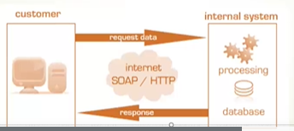

**SOAP API:-**

* Stands for Simple object Access Protocol
* Uses WSDL(Web Service Description Language) to contact with the endpoints which is based on XML format.
* It provides response in XML only.
* It has 3 main components in its SOAP Message

1. SOAP Envelope
2. SOAP Header
3. SOAP Body (includes payload ,error messages)

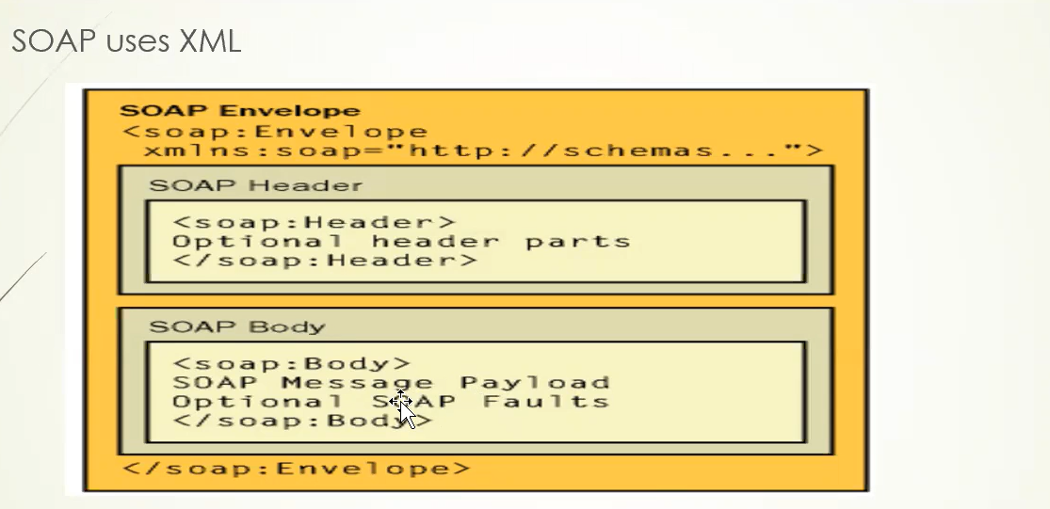

* 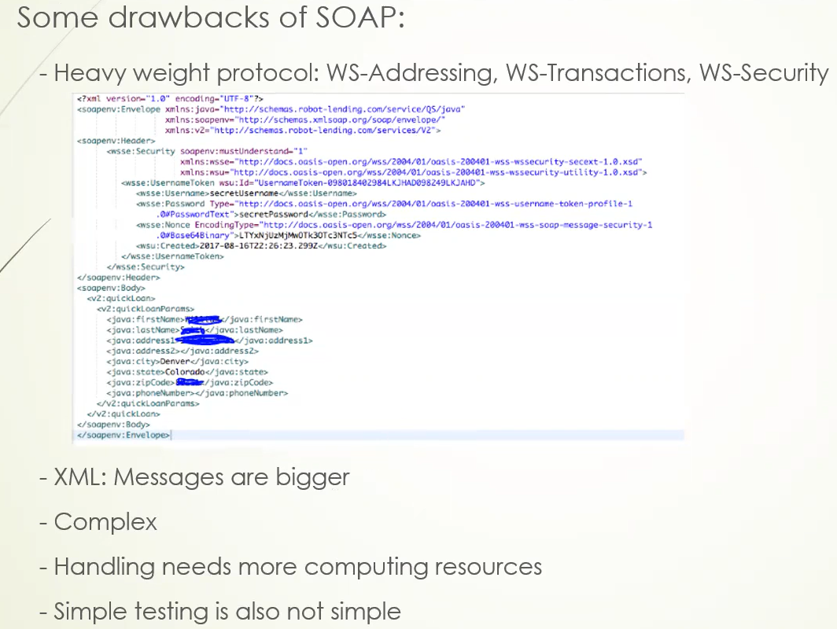

**REST API:**

* Stands for Representational State Transfer.
* Features:

1. Client Server
2. Stateless
3. Cache
4. Uniform Interface
5. Layered System
6. Code on Demand

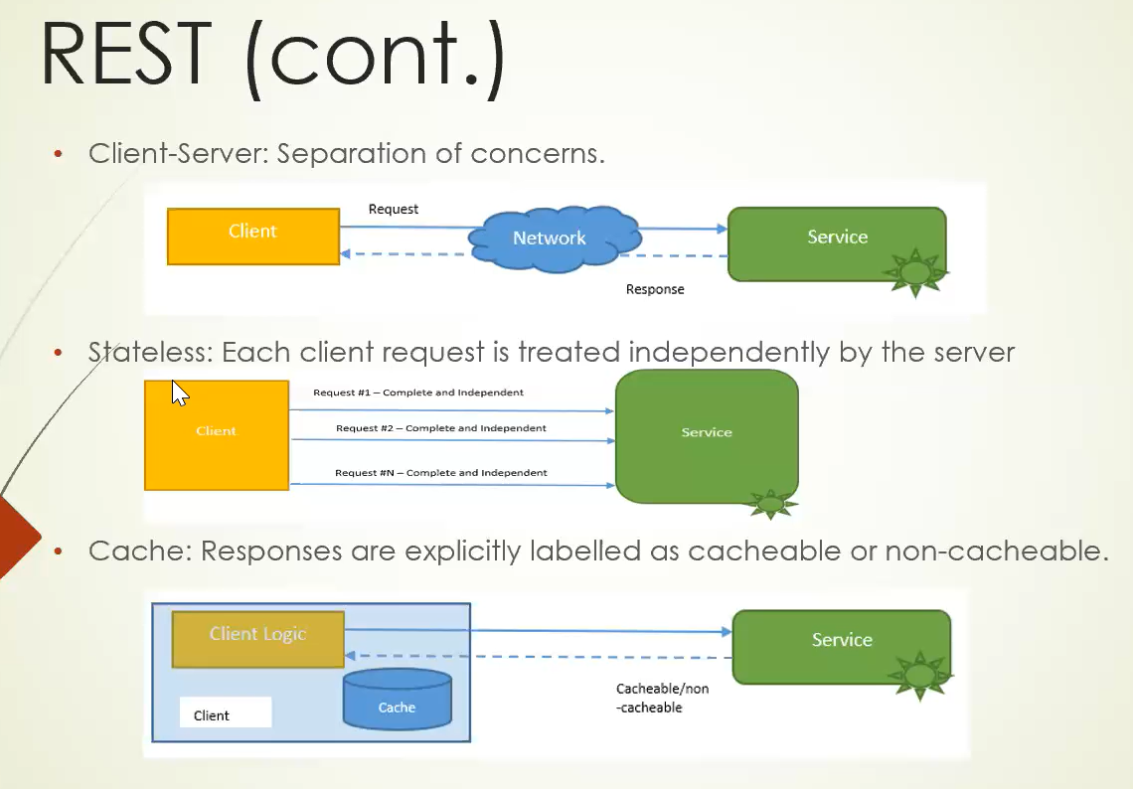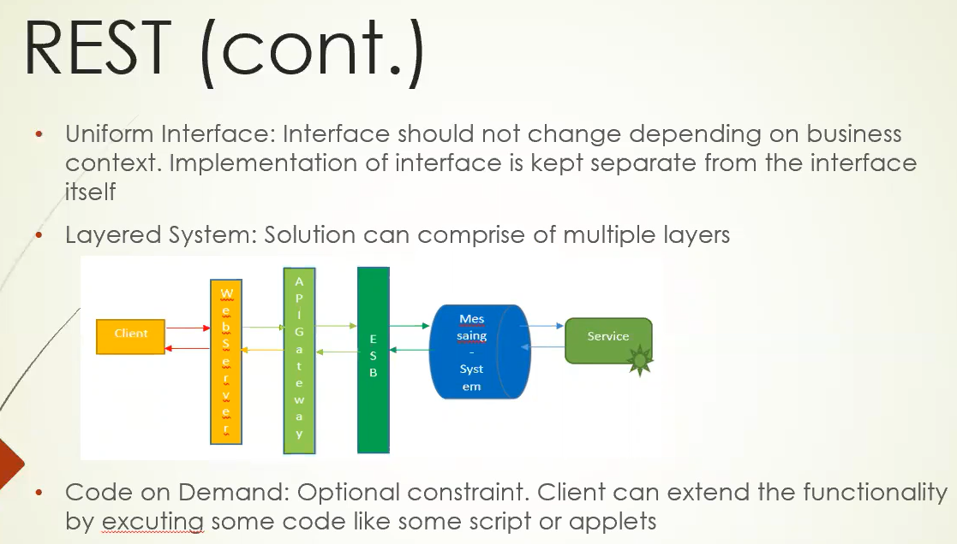

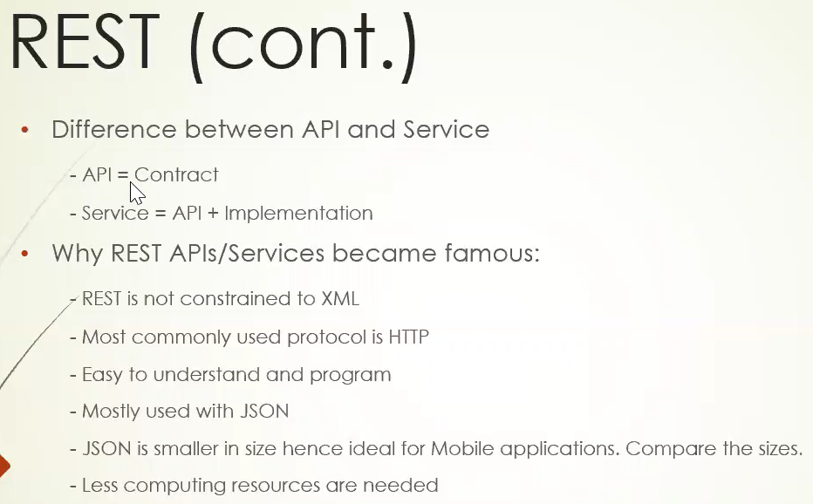

**API Management:**

* 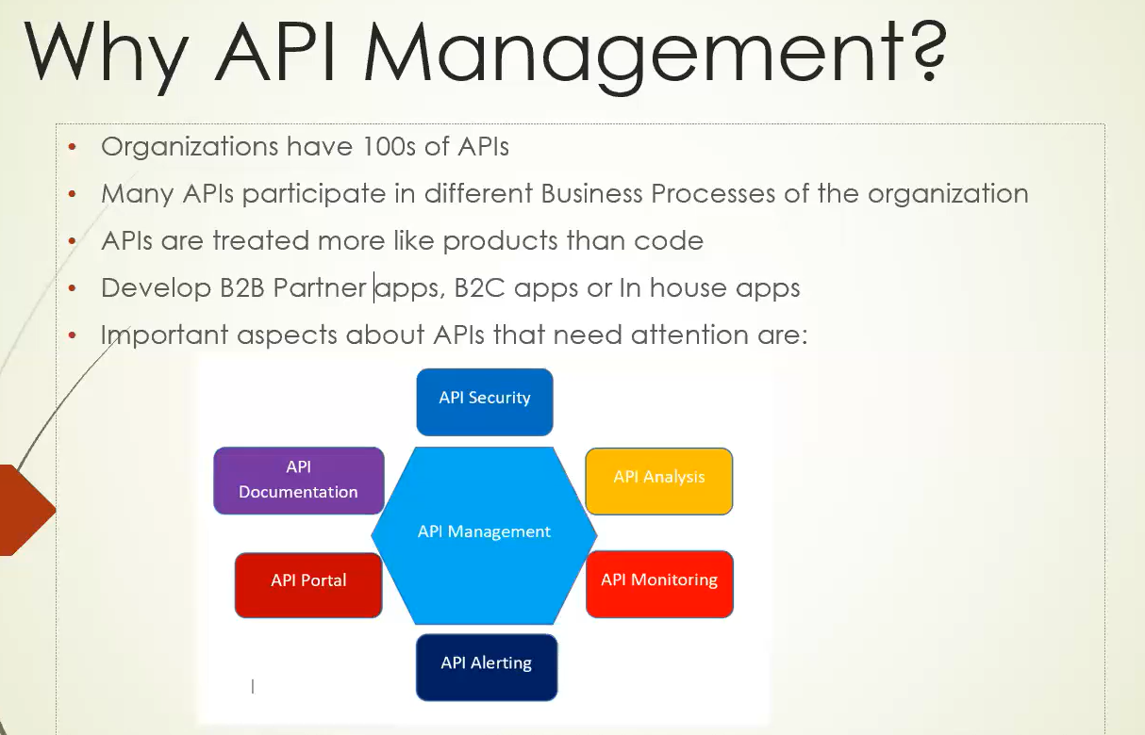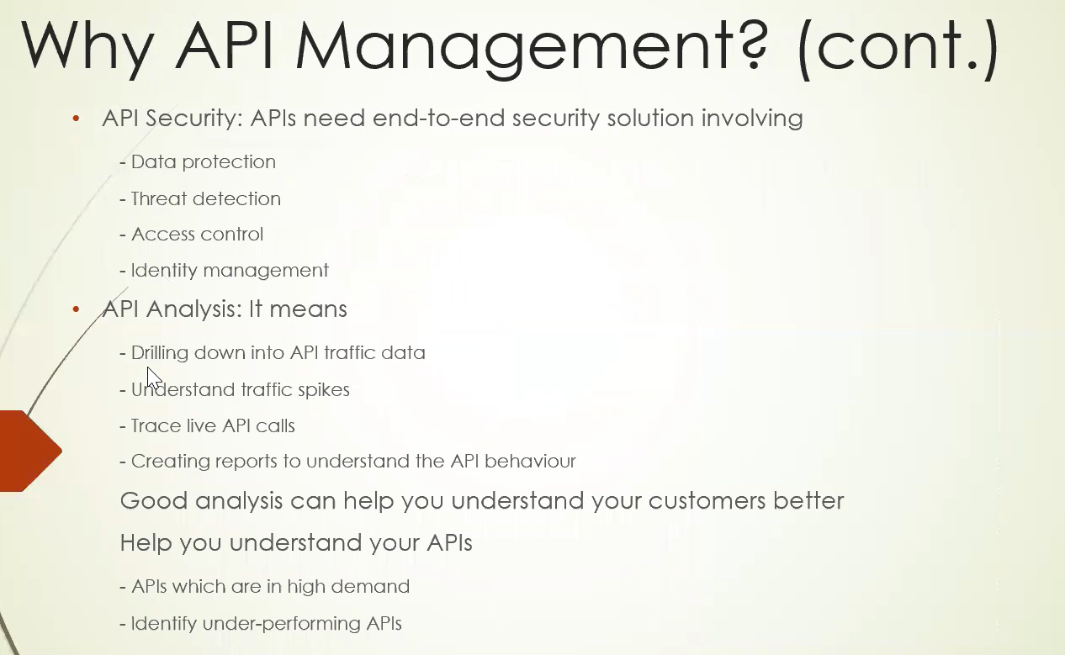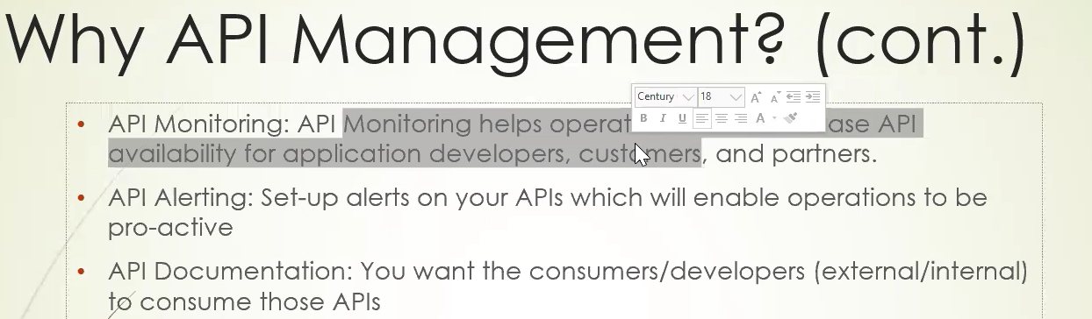

**Users API:**

* Users API is demo API on [SwaggerHub.com](https://app.swaggerhub.com/home) used for practicing all API Management concepts of APIGEE.
* Users API is built on OAS 3.0 (open API Specification 3.0) language

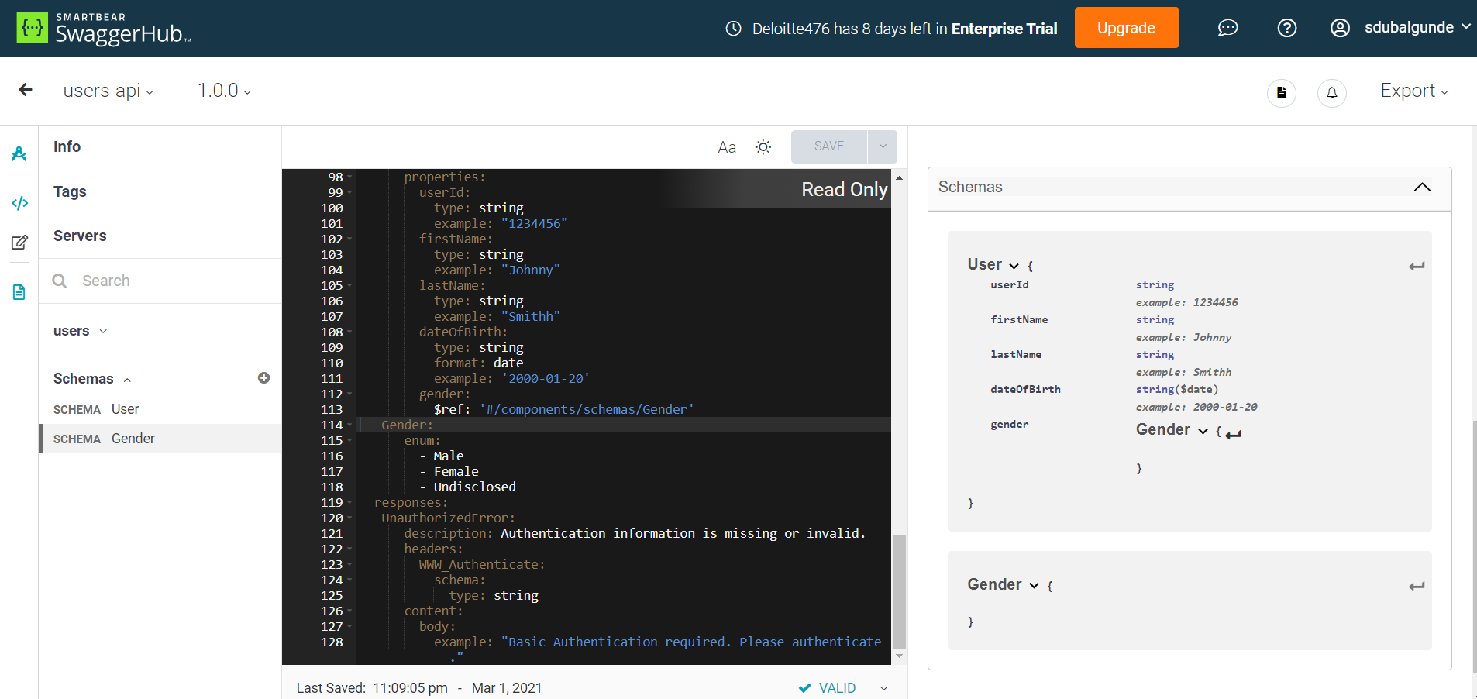

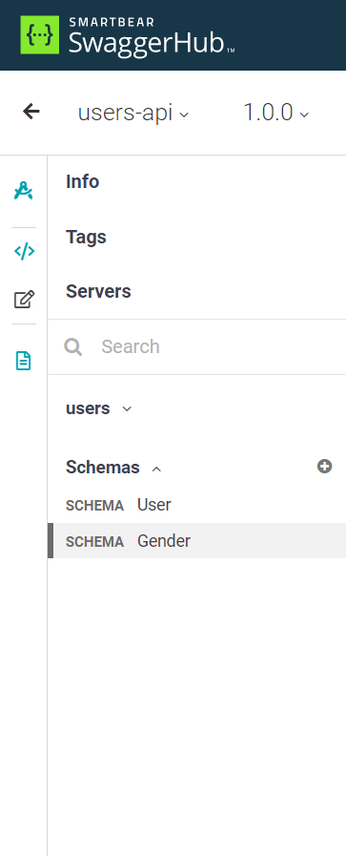

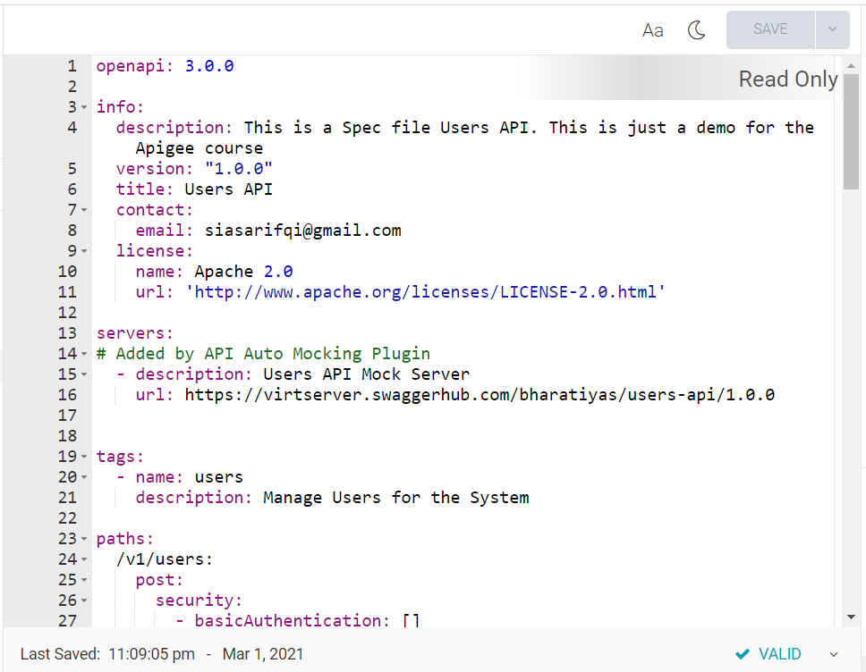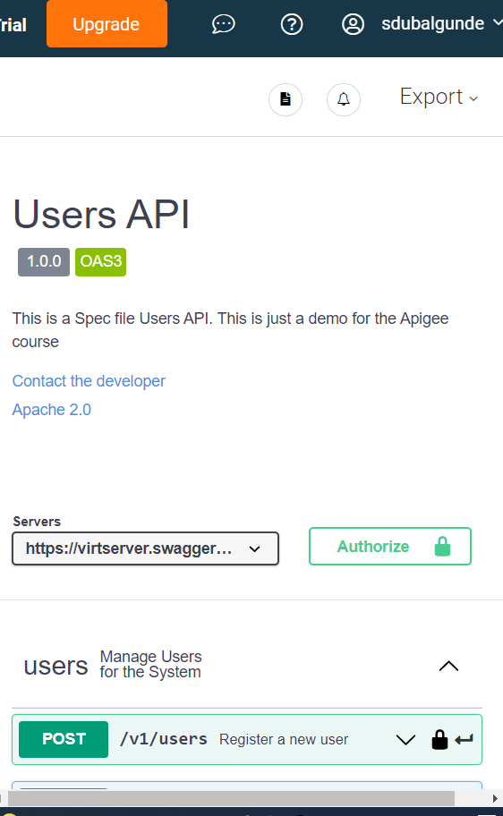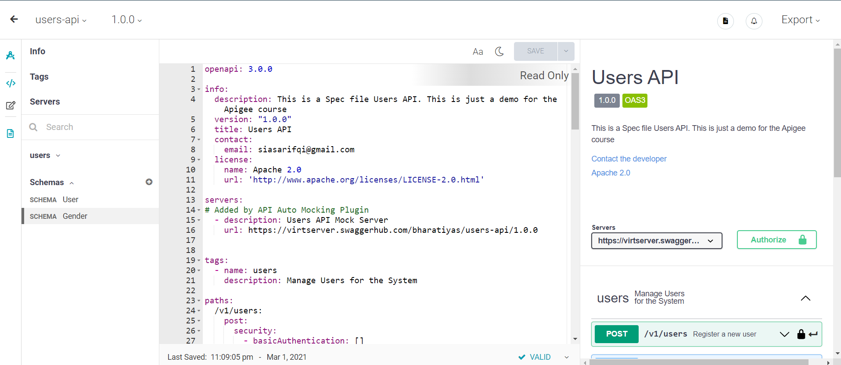

* Users API has 3 calls

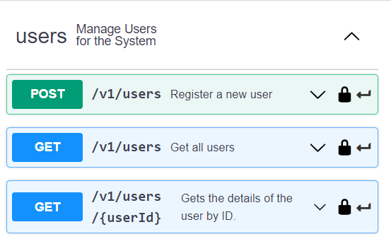

* Users API File



* **Github link to users-api:** [**https://github.com/amazeittech/users-api/archive/master.zip**](https://github.com/amazeittech/users-api/archive/master.zip)

**Running Users API on Local Machine:**

* As we know, APIGEE is an API mgmt. tool managed on Cloud so to manage API we need to have API running on internet server .for this demo we are using Users API that will run on local machine(local server [http://localhost:8080] ) where we will use ngrok tool to expose our local server to internet so that we can apply all concepts of APIGEE on our Users API.
* **To run the Users API on local machine** we need to have **JAVA JDK installed** this is becoz Users API is built on Spring framework n Spring comes under Java.

1. Minimum JDK Version: JDK8
2. After installing JDK need to setup Java_Home(c://users/downloads/jdk….) , update Path Variable(%Java_Home%/bin) or Just update Path variable(c://users/downloads/jdk…../bin) .
3. After setting the variables to test whether java is installed correctly or not open cmd n type java -version. To check the path variable value type echo “%path%”.

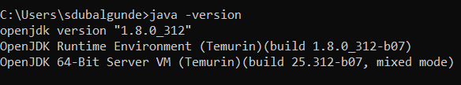

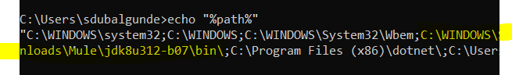

1. To run the users api in local ,Need to download the users-apis.jar file from the github link that is shared

[**https://github.com/amazeittech/users-api/archive/master.zip**](https://github.com/amazeittech/users-api/archive/master.zip)

It will download the .zip file we need to unzip at some location (c:/users/Desktop/) n in the same location of file explorer we have to type cmd so that command prompt will directly open and point to the same location (c:/users/Desktop/) once cmd opens in same location as jar file contains then type **java -jar jarfilename.jar** (java -jar users-apis.jar)

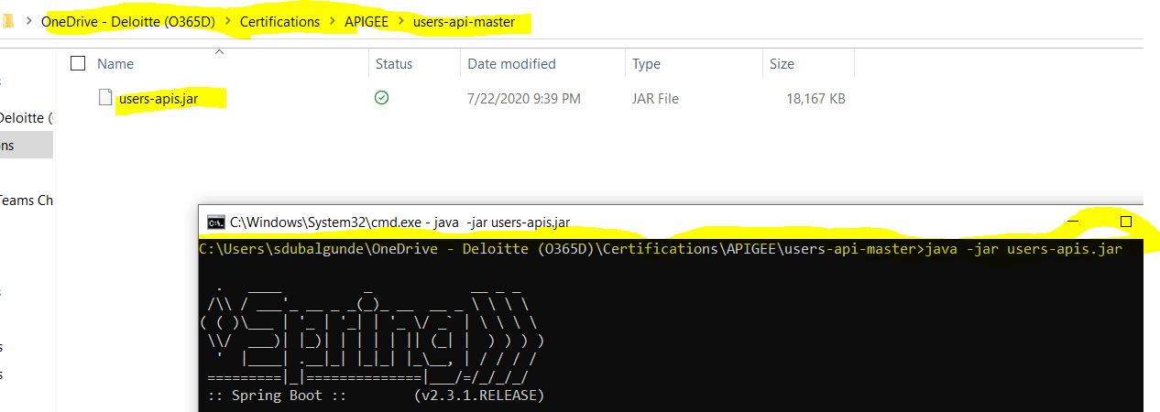

This will start running the users-apis.jar api in local. 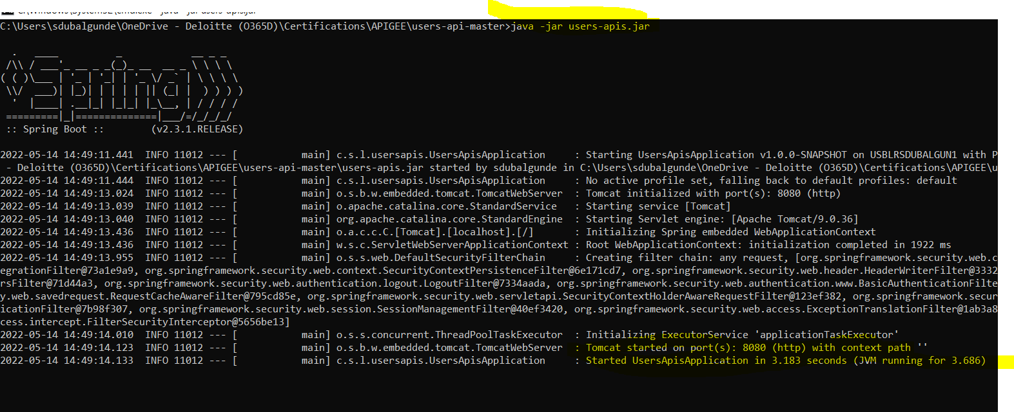

* For Testing the User API we need to have postman downloaded .to download postman go to this link

<https://www.postman.com/downloads/>

once downloaded open the postman app n create a collection (APIGEE Udemy Course Learning-Become a Guru in Google Apigee API Management Platform ) where you can store all ur API requests under one hood.

To start testing your Users Api create or add a request under that collection.since we have 3 calls in users api

1. Post /v1/users register a user
2. Get /v1/users get all users
3. Get /v1/users/{userid} get specific user

We create 3 diff request for each of them

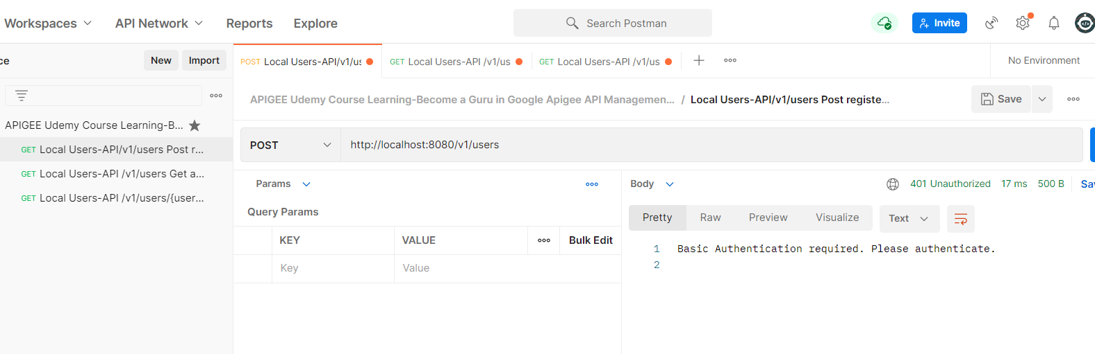

For creating the API url we will use below syntax n will use correct method(get,post)

<http://host:port/endpoint>s

post <http://localhost:8080/v1/users>

get <http://localhost:8080/v1/users>

get <http://localhost:8080/v1/users/1>

once url is done will click on send button in postman but since Users API needs **Basic Authentication** i.e username n password we will get response like Basic Authentication required.please authenticate.

For resolving this we can add username n pwd in **Authorization tab** by selecting type as **Basic Auth** n **username as sysuser n pwd as syssecret.**

For post call need to add below request body in body tab n basic authentication details in auth tab

{

    "firstName": "Onefn",

    "lastName": "Oneln",

    "dateOfBirth": "2001-05-14",

    "gender": "Female"

}

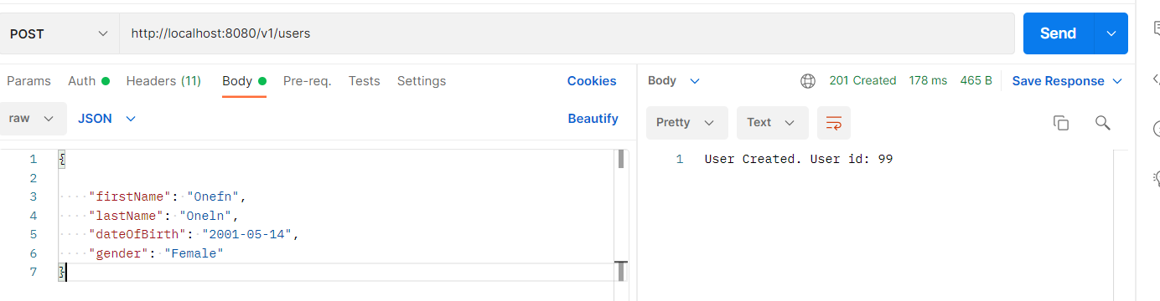

For get /v1/users call we need to add basic authentication details in auth tab

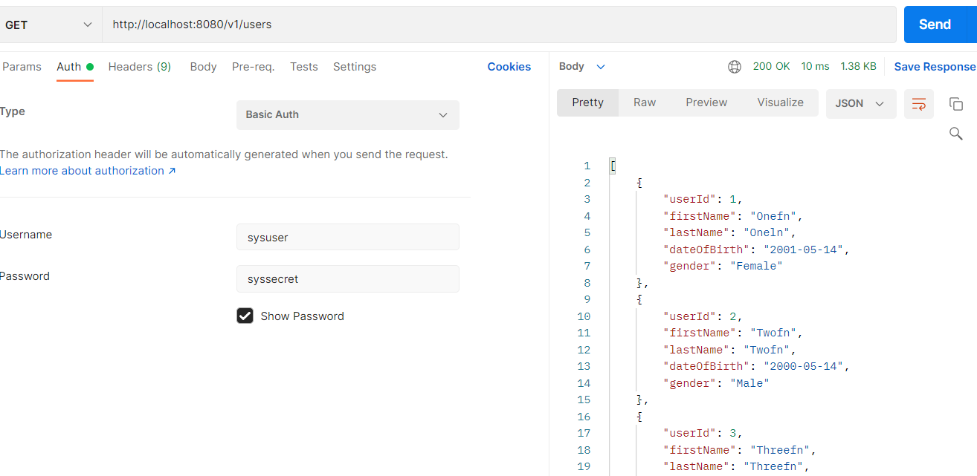

For get /v1/users/{userid} call we need to add basic authentication details in auth tab

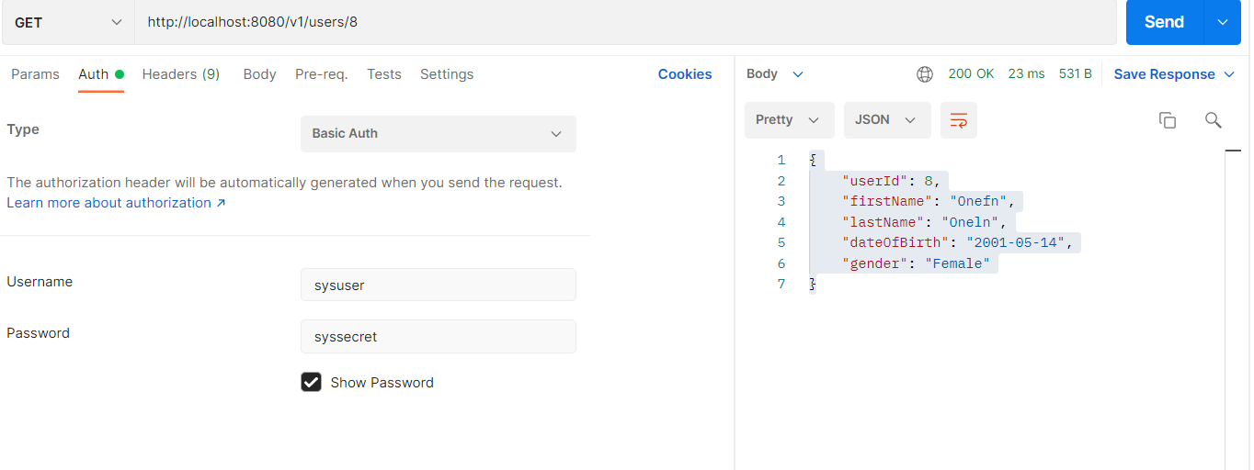

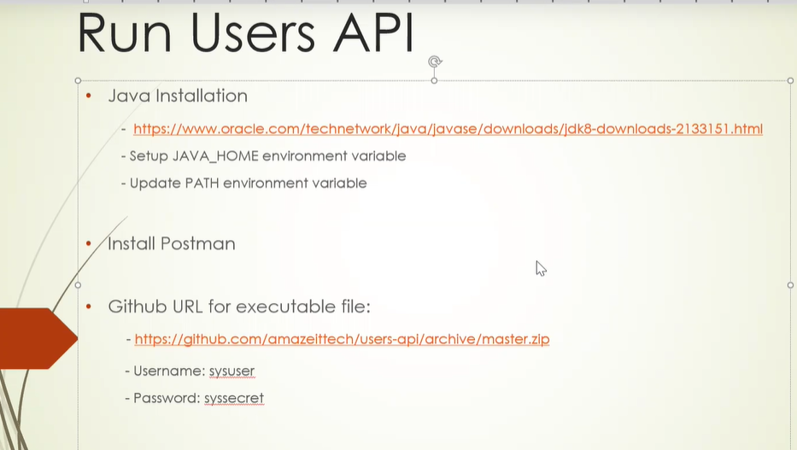

**Exposing local machine to internet:**

* We ran Users api successfully in local but the problem is Apigee is a cloud hosted tool n to manage the Users api on Apigee our Users api should be available on net to do so what we can do is

1. Deploy the Users api on cloud platform like aws ec2,GCP or Azure platform.
2. Use some tool like ngrok which allows our local machine to be exposed to internet.

In this case we will use ngrok,go to ngrok website

[ngrok](https://ngrok.com/)

create an account using new id,gmail or github.

Once done,download ngrok open the zip file ,unzip it run the .exe file

Once cmd opens up type **ngrok.exe http 8080**

This command will tell the ngrok to expose http n port 8080 to be exposed to internet

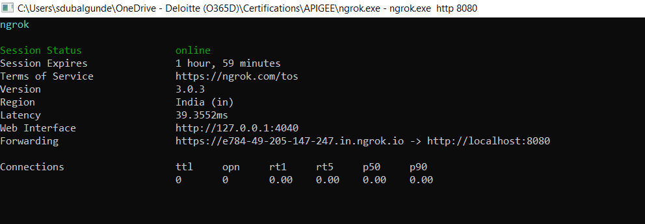

From above screen we can take Forwarding <https://e784...io>

Link n replace it with <http://localhost:8080> in postman’s Users Apis Request. N click send button.

So what’s happening here is all the requests that will be coming thru postman or any thing on <https://e784......io> will be forwarded to <http://localhost:8080> n <http://localhost:8080> will give response to <https://e784......io> n then <https://e784......io> will provide the response to the calling tool like postman or anything .

They will still work as 8080 is exposed to internet with https connection.

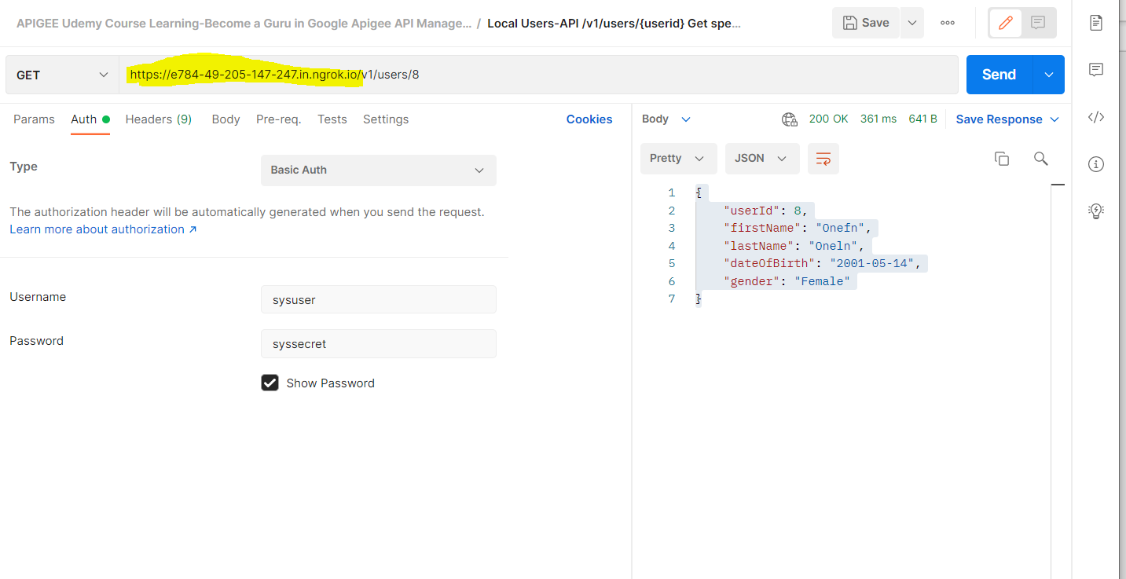

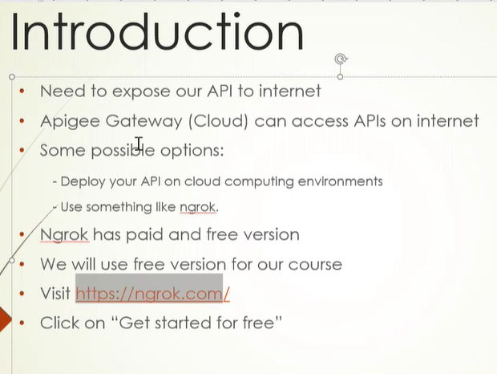

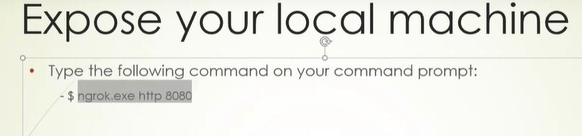

**APIGEE Introduction:**

* 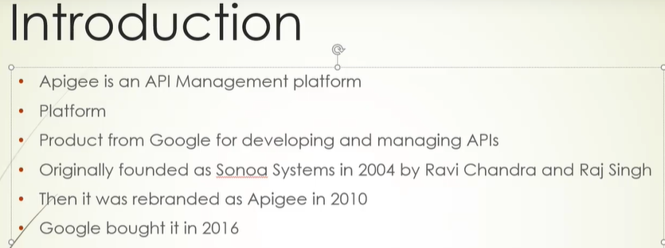 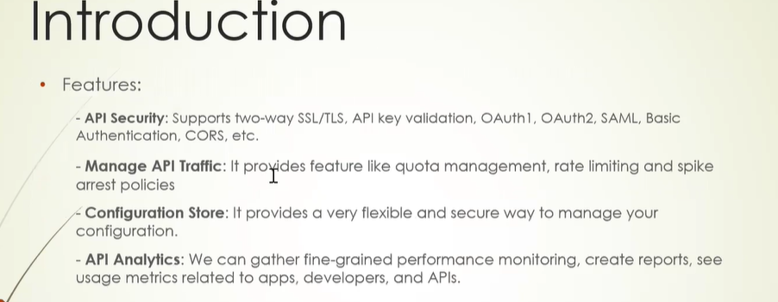 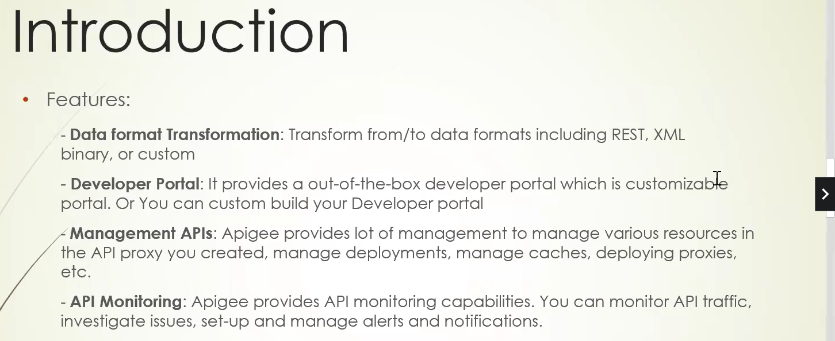 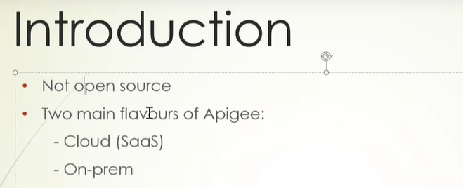

Creating Free Apigee EDGE Account:

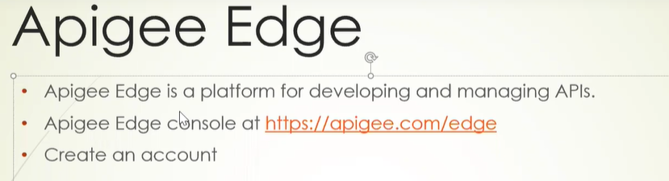

<https://apigee.com/edge>

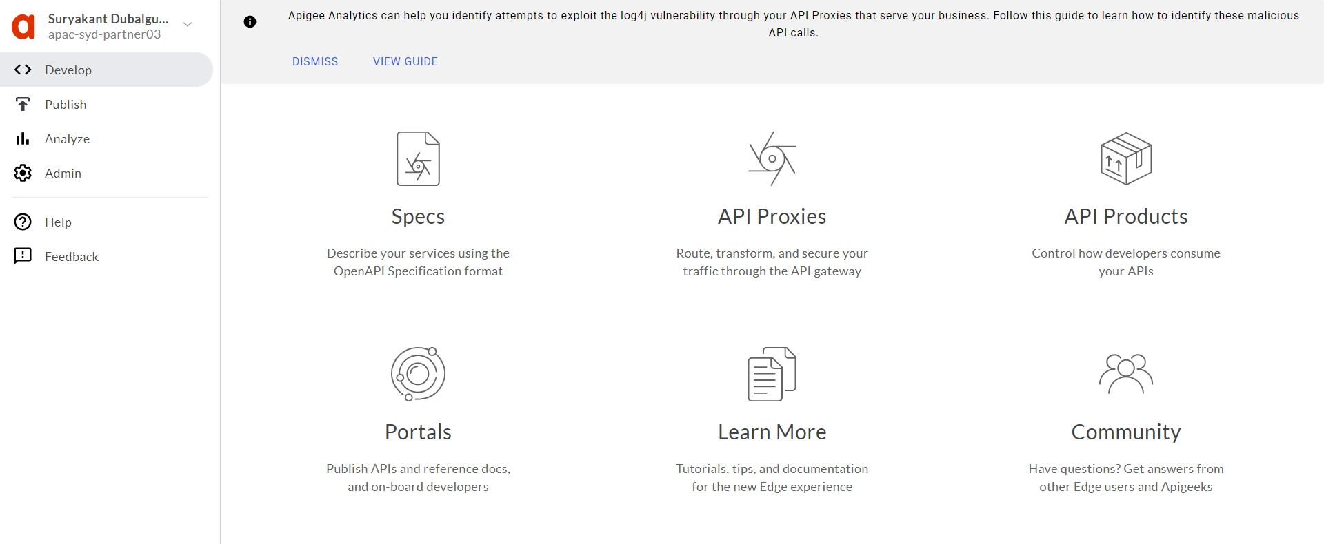

The Main screen is divided into two parts:

1 part (left part represents all the menus like develop,publish,,analyze,admin etc…

2nd Part (right part contains quick links for some of the functionalities provided by APIGEE)

**Exposing Users API to APIGEE Cloud**

* Till now what we have done is

Firstly, we deployed Users API on local server

Secondly we exposed http port 8080 to internet using ngrok tool which exposes our Users API to Internet(Cloud) so that Users API can be managed by APIGEE (Cloud Platform)

* Now we need to create API Proxy for Users API using APIGEE platform,this proxy will act as a frontier for all the client request .Proxy will listen to all client requests-(postman,ARC,Any application) n forward the request to actual API n get the response back from actual API n deliver the response back to the client.

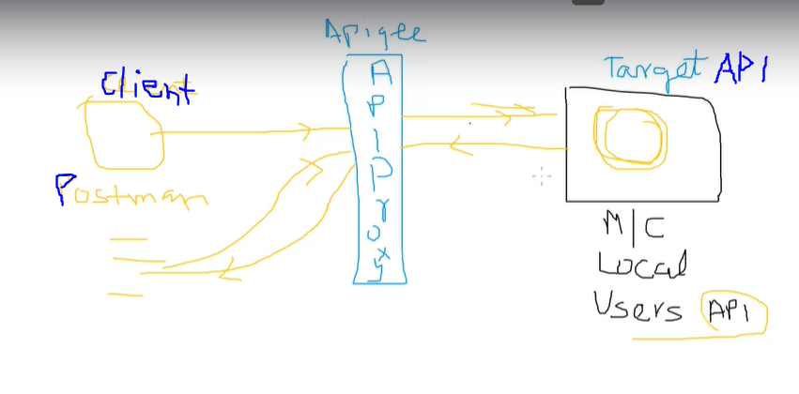

Steps to create API Proxy:

1. Login to APIGEE Edge n click on API Proxies on the landing page or go to develop->API Proxies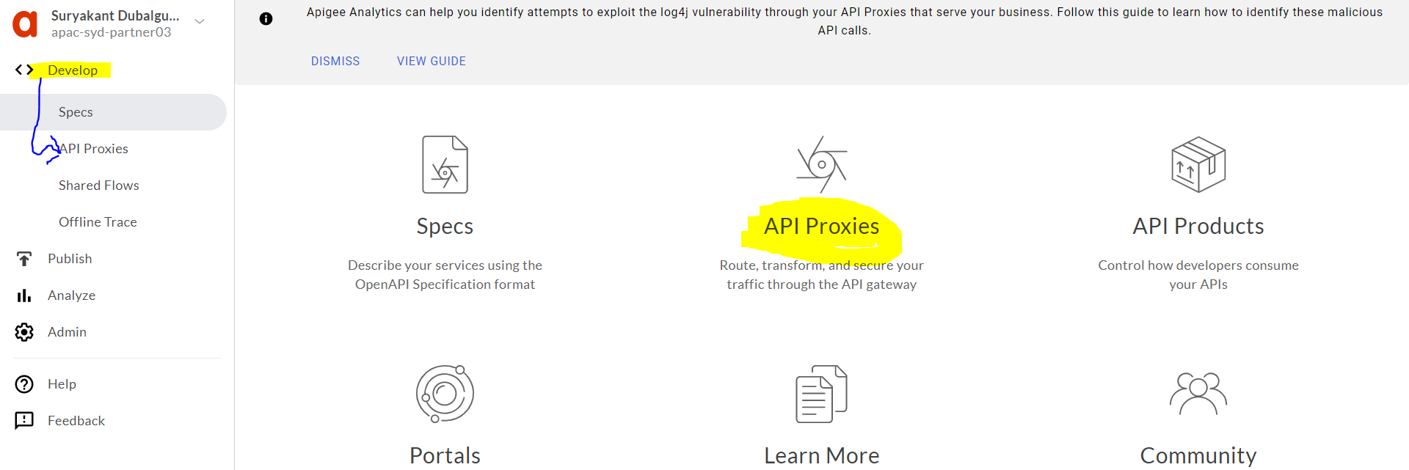
2. U will see list of proxies created in APIGEE under your organization to create new one click on +proxy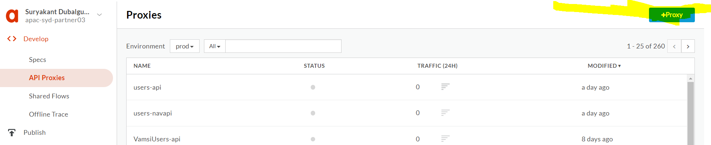
3. Once clicked you will get list of templates like reverse proxy,no target etc.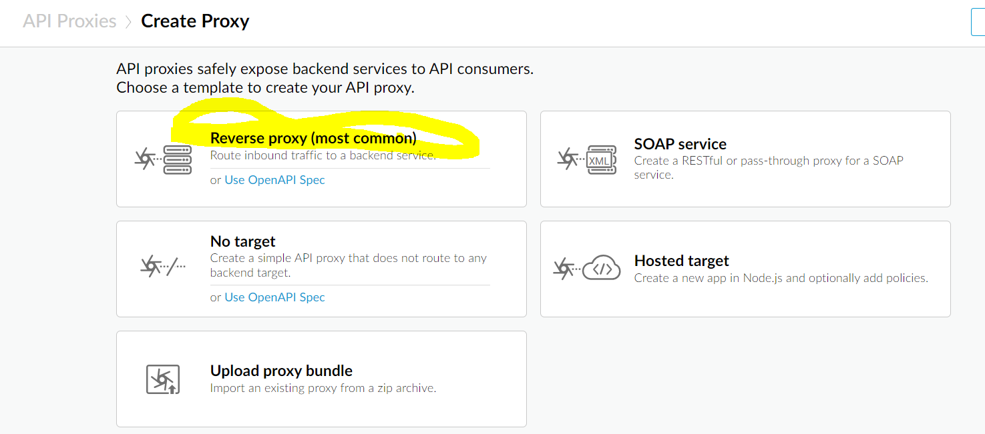
4. Select Reverse Proxy in our case n in next page enter details like below

Target =hostname where the API is running, in our case our actual users-apis.jar file is running on localhost but we are exposing our localhost Users API to internet using ngrok tool which creates forwarding host for localhost.so in our case ngrok’s hostname will be Target here.

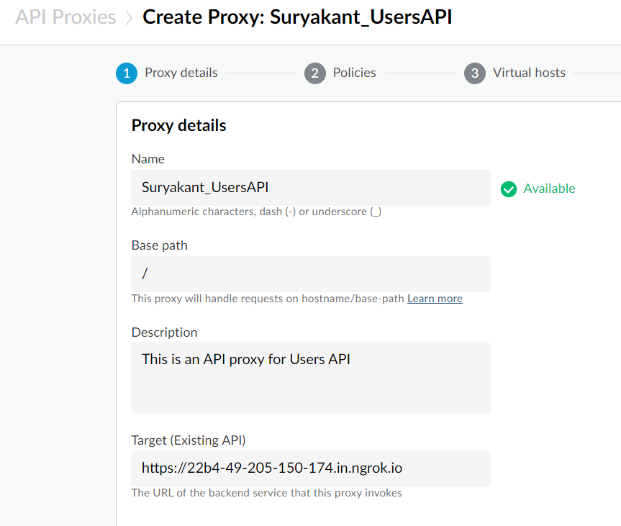

On next screen, if u want apply policies on API Proxy created then you can select here I used pass through(no authorization).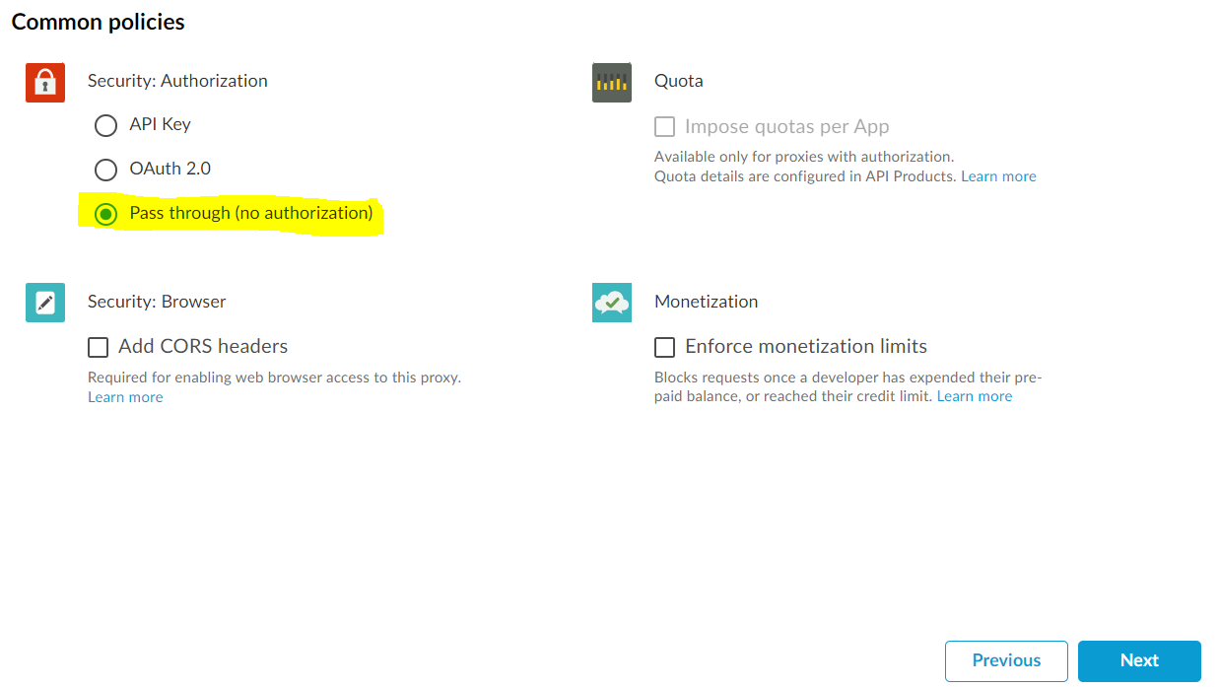

On next screen , we need to select either we need http or https host for API Proxies.

After you create an API proxy on Edge, the default URL that an app uses to access the proxy has the form:

http://{org-name}-{env-name}.apigee.net/{base-path}/{resource-path}  
  
https://{org-name}-{env-name}.apigee.net/{base-path}/{resource-path}

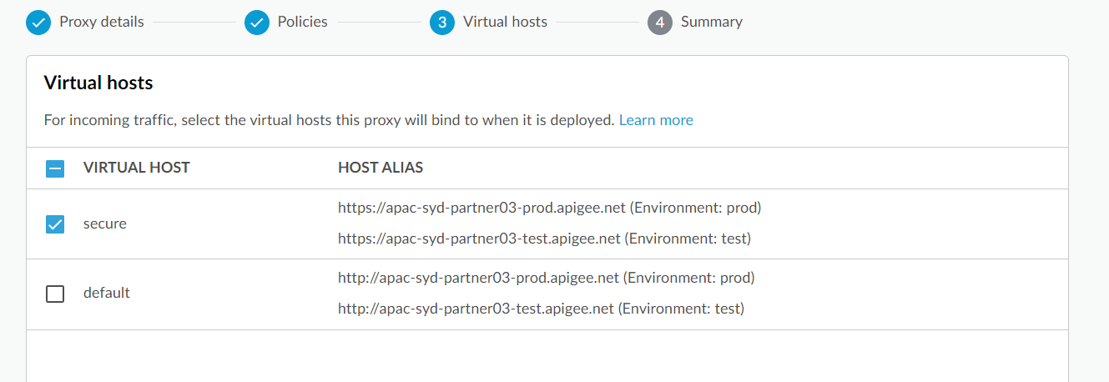

On the next screen, we will get Summary n also get a Optional Deployment where we can select in which environment we want to deploy.if we select any one or both then we can see create and Deploy button but if we don’t select any of the option then only create button will appear. 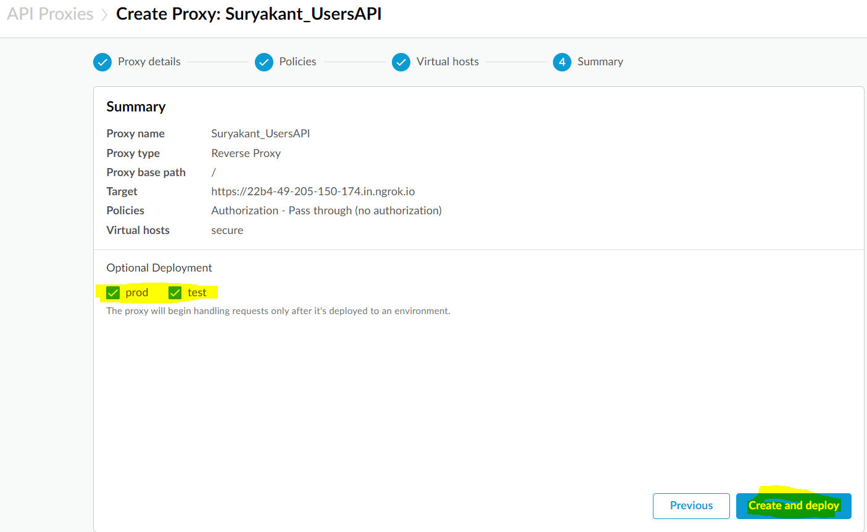



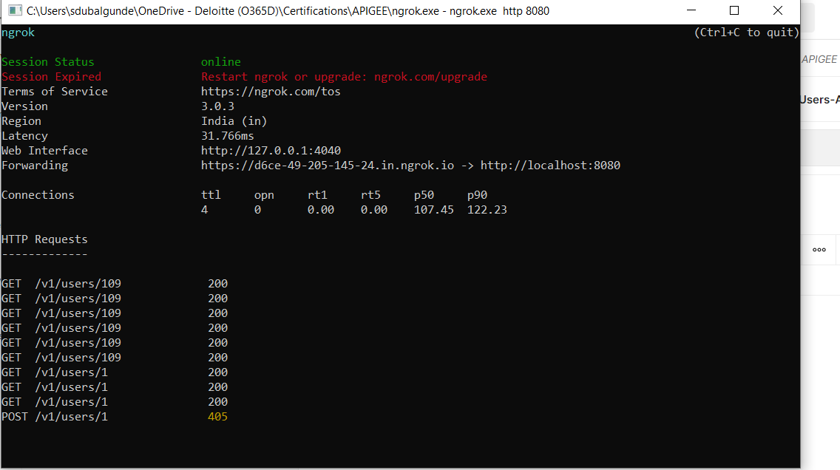

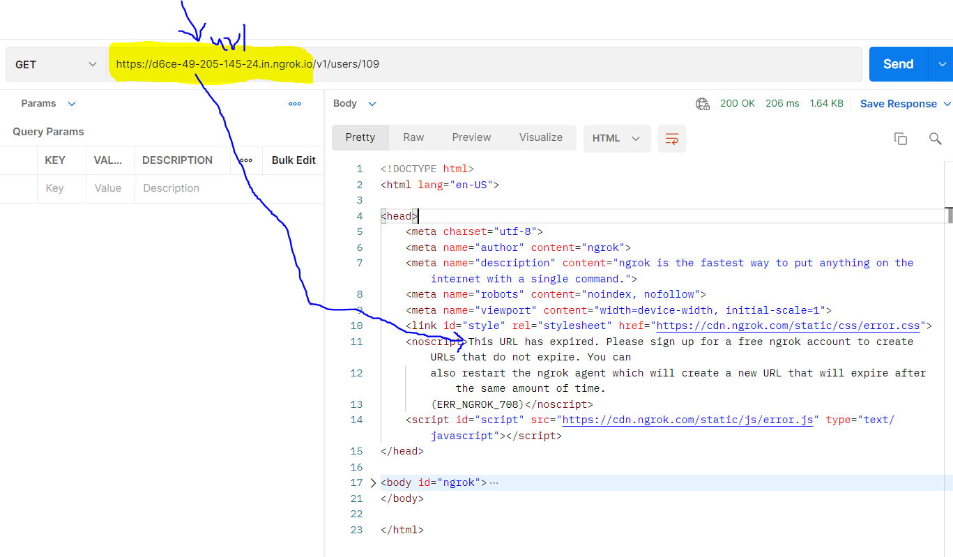

Solution:

Go to ngrok cmd prompt n then press ctrl+c this will end the session n then new window appears to create new session type the same cmd **ngrok.exe http 8080** to get new Forwarding Host n copy that host n paste it in ur postman’s request press send now it will give the expected response.

